Case study
Visual inspection on hard disk drive cases
Allied Vision’s Manta G-505B PoE and Mako G-125B PoE are used in hard disk drive case quality control

Everyone needs more storage
With ever-increasing demand of digital storage in our current society, more and more hard disk drive (HDD) have been produced over the last few decades. HDD is a data storage device that uses magnetic storage to store and retrieve digital information using one or more rigid rapidly rotating disks coated with magnetic material. While HDD manufacturers continue to increase their hard disk drive production, the quality control of producing HDD has become more vital as product characteristics have evolved to be more complex – calling for higher production accuracy with shorter production lead time.
It is also crucial for HDD to be perfectly fitted and sealed in its case. The case will ensure all components are perfectly secured in its place and the mechanics work well over the lifetime of the product. It also will offer protection to the sensitive magnetic drive from dust, humidity as well as resistance to shocks or vibrations.
Hard disk drive case quality control
In order to make sure that HDD are perfectly secured, manufacturers of HDD cases have to make sure that there are no defects or incomplete machining on HDD cases’ thread holes. Flexon Technology, system integrator located in Thailand, is specialized in customized design of manufacturing equipments such as vision inspection systems, automatic-optical inspection modules, automatic machines and software for data management.
Flexon has developed Visual Machine Inspection (VMI), to inspect Hard Disk Drive cases for missing thread , incomplete thread, thread damage and incomplete or wrong machining. The inspection is done for the top, side and back of the case using Allied Vision’s Mako G-125B PoE and Manta G-505 PoE.
Mako G-125B PoE is a GigE machine vision camera that incorporates the high-quality Type 1/3 (6.0 diagonal) Sony ICX445 CCD sensor with EXview HAD technology. At full resolution, this camera runs 30.3 frames per second. With a smaller region of interest, higher frame rates are possible. Mako G-125B PoE has the same ultra-compact form factor and the same mounting positions as many analog cameras. It includes Power over Ethernet (PoE), three opto-isolated outputs, and a 64 MByte image buffer. The image quality profits from the precisely aligned sensor.
Manta G-505B PoE is Allied Vision’s versatile GigE vision camera with a wide range of features. It incorporates the high-quality Type 2/3 (11.016 mm diagonal) Sony ICX625 CCD sensor. At full resolution, this camera runs 15.0 frames per second. With a smaller region of interest, higher frame rates are possible. Particular highlights of this camera are the three look-up tables, sophisticated color correction capabilities, a robust metal housing, and many modular options.
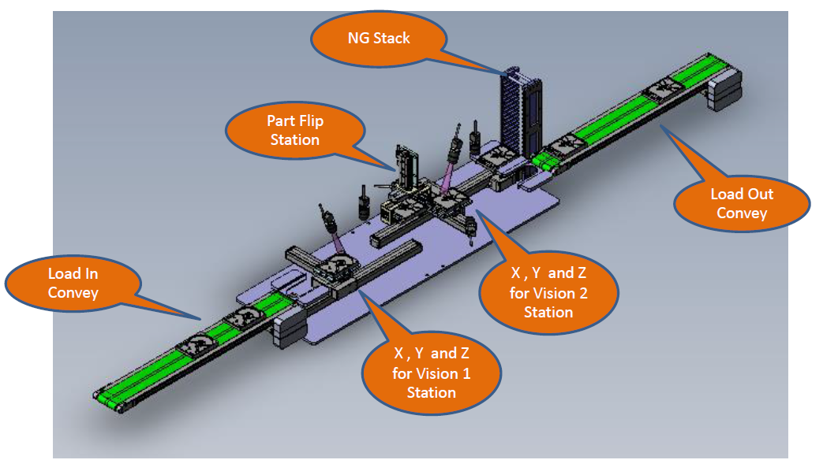
There are 2 stations in each VMI machine, Vision 1 station and Vision 2 station. The HDD cases will be loaded onto the load in conveyor and the first stop will be Vision 1 station.

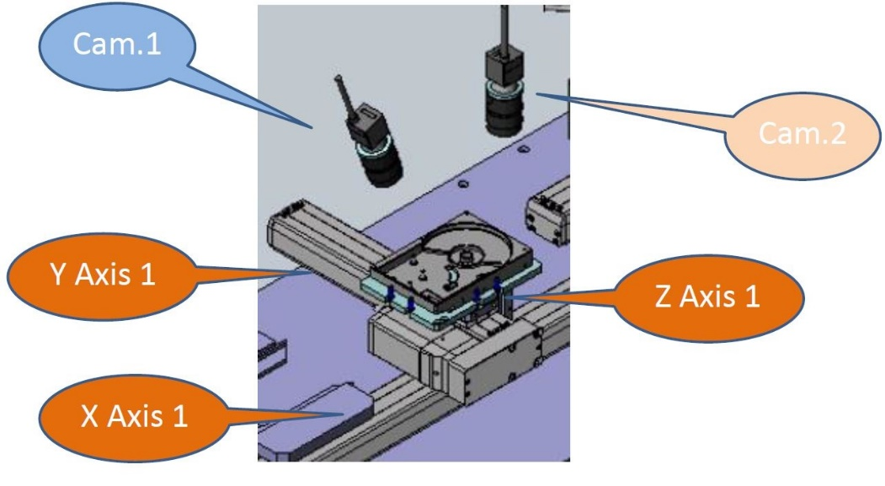
Vision 1 station is fitted with 2 cameras, Cam.1 is Mako G-125B PoE and Cam.2 is Manta G-505 PoE.
Mako G-125B PoE is used for defect inspection of the top part of the HDD case. The defects criteria include missing or incomplete thread, thread damage, missing machining surface and missing drill.

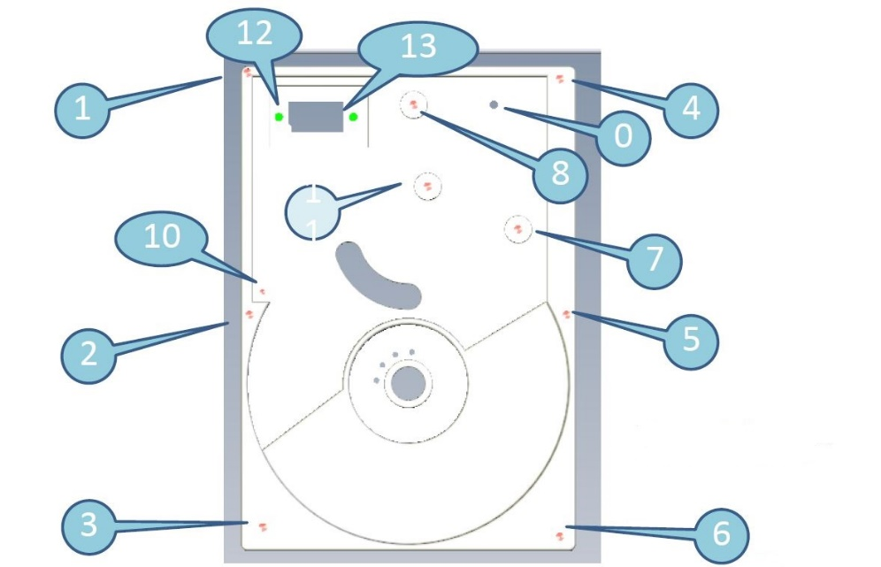
Manta G-505B PoE is used to locate the position and Mako G-125B PoE capture 14 shots located by Manta G-505B PoE in this station within 4.2 seconds.

11
Once the inspection on Vision 1 Station is completed, the HDD case will proceed to the flip station before it arrives at Vision 2 Station. There are 4 cameras in Vision 2 Station. Camera 3, Camera 4 and Camera 5 are Mako G-125B PoE and Camera 6 is Manta G-505B PoE. Camera 3 and camera 4 are inspecting the sides of the HDD case for missing or incomplete thread. Camera 5 inspect the back part of the HDD case for missing or incomplete thread, missing riveting, missing drill, machining surface as well as part number reading while camera 6 locate the location of the thread hole.
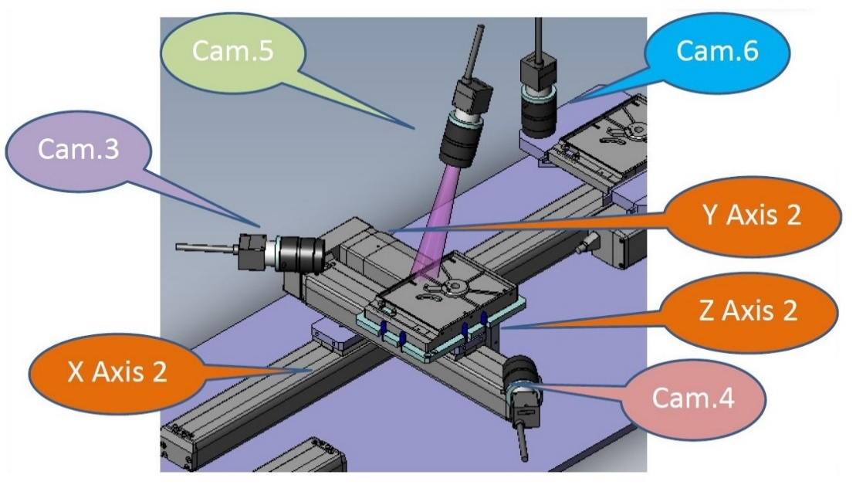
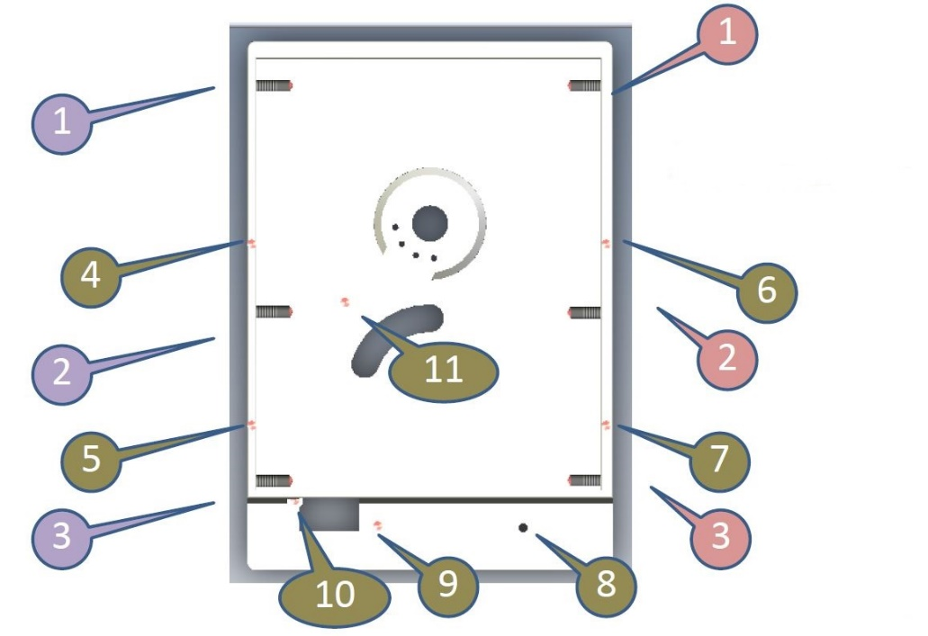

The cycle time in this station is 4.8 seconds with 14 shots in total taken by Camera 4, Camera 5 and Camera 6. After the inspection in Vision 2 station is completed, the HDD case will proceed to the load out conveyor if all the conditions are met. If the HDD case fails the inspection it will go to the rejected pile (NG stack).
With VMI machine in production line, HDD case manufacturers are able to increase their productivity and accuracy of HDD case quality control inspection. This is crucial in order to fulfill the high demand of HDD in the market.
“The combination of high resolution versatile GigE model, Manta G-505B PoE and ultra-compact yet affordable Mako G-125B PoE is great for the Visual Machine Inspection ( VMI ) as it fits all the requirements. We also enjoy the great support from Dynatech Instrument, Allied Vision’s partner based in Thailand“ stated Somporn K., owner of Flexon Technology.

Profile of Allied Vision
For over 25 years, Allied Vision has been helping people to see the bigger picture. Allied Vision supplies camera technology and image capture solutions for industrial inspection, science, medicine, traffic monitoring and many more application areas in digital imaging. With a deep understanding of customers’ needs, Allied Vision finds individual solutions for every application, a practice which has made Allied Vision one of the leading camera manufacturers worldwide in the machine vision market. The company has eight locations in Germany, Canada, the United States, Singapore and China and is represented by a network of sales partners in over 30 countries. www.alliedvision.com

Contact (Company Headquarters):
Allied Vision Technologies GmbH | Taschenweg 2a | 07646 Stadtroda, Germany
Tel.: +49 36428/677-0 | Fax: +49 36428/677-24 | info@alliedvision.com | www.alliedvision.com

Media Contact:
Jessica
Allied Vision Technologies Asia Pte. Ltd.
82 Playfair Road
#07-02 D'Lithium
Singapore 368001
Tel.: +65 66349027
Fax: +65 66349029
jessica@alliedvision.com

