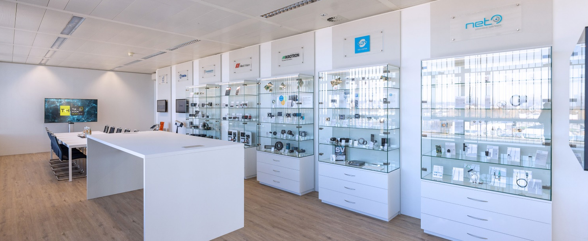

TKH Vision Group introduces innovative TKH Vision Solution Center for integrated machine vision solutions
Konstanz, January 18, 2023

TKH Vision, a leading group of machine vision companies and part of the TKH Group, is proud to announce the official opening of the TKH Vision Solution Center in Konstanz, Germany. The TKH Vision Solution Center will serve as demo and experience center for TKH Vision’s integrated machine vision solutions. It is located at the Chromasens headquarters in Konstanz.
Given its broad portfolio of machine vision products and know-how, TKH Vision provides cross-platform and cross-technology integrated turnkey vision solutions for OEM’s, machine builders and system integrators. TKH Vision manages the complexity of machine vision for customers and develops, in close coordination, a unique series production solution that is perfectly designed to meet their application requirements.
Our in-house experts develop integrated solutions from a large variety of area scan, line scan, and 3D vision technologies supporting all spectra from UV to SWIR using highly sophisticated light and optic sub-systems in combination with state-of-the-art software products.
"The TKH Vision Solution Center is a meeting place where prospective customers can come and see our 2D & 3D machine vision solutions in action. Here we take care of any application requirement and provide integrated, turnkey vision solutions for machine builders and integrators, says Mark Radford, Vice President of TKH Vision and CEO of LMI Technologies. “We manage machine vision complexity of our customers worldwide and, in close cooperation, develop unique serial production solutions that are perfectly designed to fit the application requirements.", adds Martin Hund, CEO of TKH Vision Solution Center and of Chromasens.
The TKH Vision Solution Center is an extensively equipped demo and experience center which highlights the capabilities, expertise, products and technologies of the TKH Vision group of companies: Allied Vision Technologies, Chromasens, LMI Technologies, Mikrotron, Nerian, NET, SVS-Vistek and Tattile. The Center allows TKH Vision to work directly with customers on their requirements, to sketch initial solutions on digital whiteboards and to demonstrate initial technical approaches in instant set-ups.
The test labs feature a variety of live demos from all the TKH Vision companies, demonstrating the use and benefits of their respective products.
TKH Vision invites all interested parties to visit the Solution Center to work with them on their individual solutions.

A press kit with images and logos can be downloaded here:
Press kit

For more information, contact:
Martin Hund, CEO of Chromasens and TKH Vision Solution Center
solution-center@tkhvision.com

Press contact:
Christian Behrendt, Head of Marketing, Chromasens
christian.behrendt@chromasens.de
Dan O'Connell, O'Connell Communications, Inc.
dan@oconnellpr.com

TKH Vision Solution Center
operated by Chromasens GmbH
Max-Stromeyer-Straße 116
78467 Konstanz/Germany
www.tkhvision.com

TKH Vision, part of the TKH Group, is a global technology leader in state-of-the-art integrated 2D/3D Machine Vision Solutions.
Its companies Allied Vision, Chromasens, LMI Technologies, Mikrotron, Nerian, NET, SVS-Vistek and Tattile with their wide portfolio of individual technologies are all aligned around a common mission to build long-term partnerships with their customers. The technologies are combined with internally developed software to create one-stop-shop solutions with integrated systems.
TKH Vision aims to create sustainable value for all its stakeholders and provides innovative technologies that improve efficiency, safety and robust long-life products for machine builders and system integrators for more information:
www.tkhvision.com
www.tkhgroup.com

